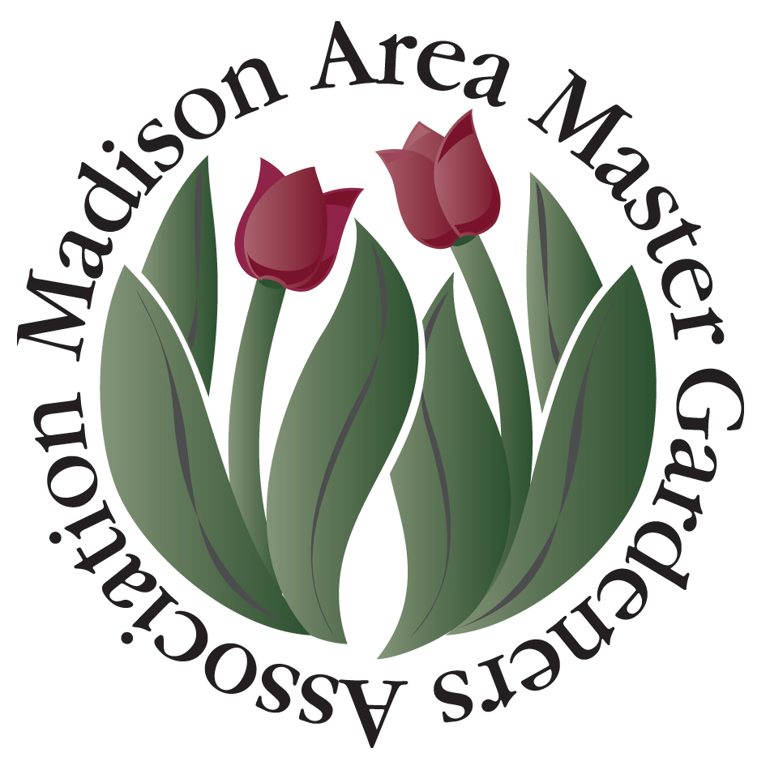

Attention MAMGA members, 2018 MAMGA Gardening Project Grant Applications are now being accepted for gardening/ horticulture projects during the 2018 calendar year!

The purpose of these grants is to help support MAMGA members with their individual and organization-sponsored community gardening projects located within the Madison area. MAMGA Gardening Project Grants cannot be used to benefit individual home gardens or private businesses.

MAMGA Gardening Project Grants must support projects that follow the criteria below and include each heading as listed in bold. Individual grant applications may be up to but no more than $500. Grant funds may be used for seeds, plants, fertilizer, mulch, tools, etc., but not for paid labor.

1. Name of person(s) applying for the grant – The project must be managed and coordinated by a current MAMGA member(s). Students currently enrolled are not eligible to apply but can assist.
2. Title of the project
3. Location of the project
4. Contact person or person’s names –Address, phone number, and e-mail address.
5. Description of the project – Describe in detail what is to be done by the project and what will the grant funds be used for? Provide a list of all persons, including volunteers, participating in the project. List a time line for the project including the completion date and describe the expected outcome of the project.
6. Community benefit –How will this project be a benefit to the
community?
7. Education –How will this project increase individual and community knowledge about gardening/horticulture and promote the exchange of gardening-related ideas and information?
8. Community Participation – Collaboration with other groups is encouraged to maximize project effectiveness. Describe the other organizations involved in the project including schools, youth, neighborhoods, businesses. What will they contribute
in time and materials?
9. Budget – Must be realistic and well thought-out. Specific budget information must be detailed for the funds requested in the application. Applicants must use the attached Budget Sheet. Successful applicants must provide receipts upon request. Funds not accounted for must be returned to MAMGA.

Applications should be no more than 2 pages in length (not including the budget sheet), double spaced. This is a competitive grant process so not all projects submitted for consideration may be funded. Each application will be reviewed carefully and applications meeting the largest number of project criteria will receive funding priority. Applicants must include the name and address of the non-profit organization they are representing so a check can be mailed directly to that organization.

All applications must be postmarked by March 21, 2018. Grant applicants will be notified by April 11, 2018. No late applications will be accepted. Applications should be emailed (NOTE: “MAMGA GRANT” in subject line) AND mailed to the address below. Grant applications and details may be found on the MAMGA website and will be sent directly to all MAMGA members via e-mail.

MAMGA c/o Sally Kefer
8001 Ritz Dr #223
Madison, WI 53719
email: sjkmail10@yahoo.com
608-843-7845

